**Question-1**

**Full_name --- First_name and Last_name**

**Salary --- Basic_Salary**

**HRA =10%**

**DA = 5%**

**PF = 7%**

**GrossSalary = Salary +HRA + DA – PF**

**Answer-**

select first_name,last_name,concat(first_name,last_name),salary,salary as basic_salary,salary*10/100 as HRA,salary *5/100 as DA,salary * 7/100 as PF, salary+salary*10/100 +salary*5/100-salary*7/100 as Gross_salary from employees;

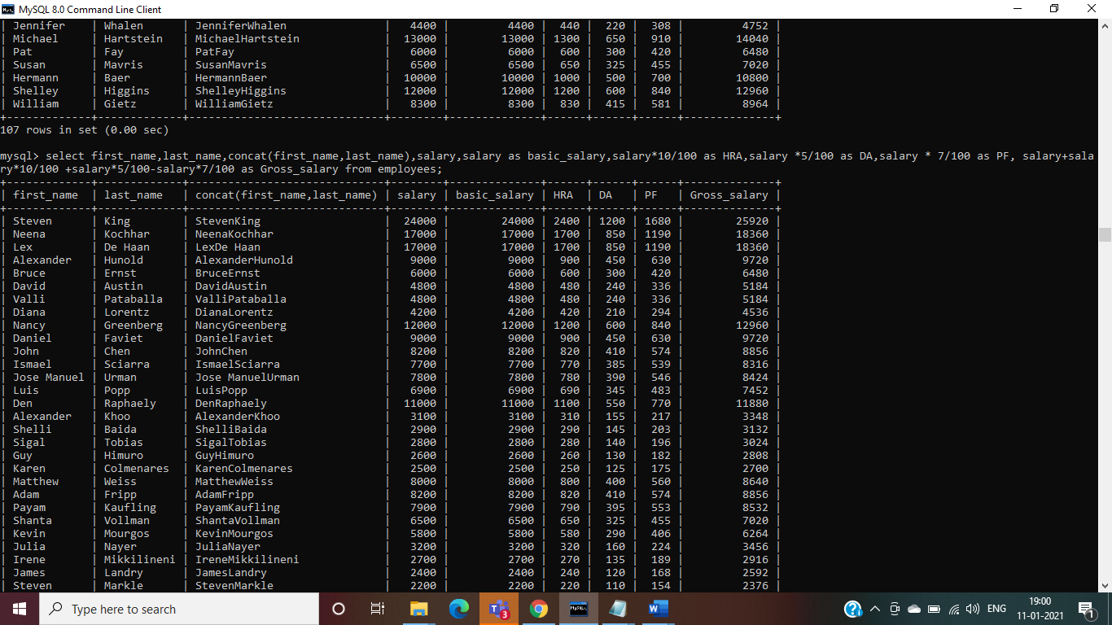

**Question-2**

**Display all employee first_name and salary where hire date between 1990 to 1995**

**Answer-**

select first_name,salary,hire_date from employees where hire_date between '1990-01-01' and '1995-12-31';

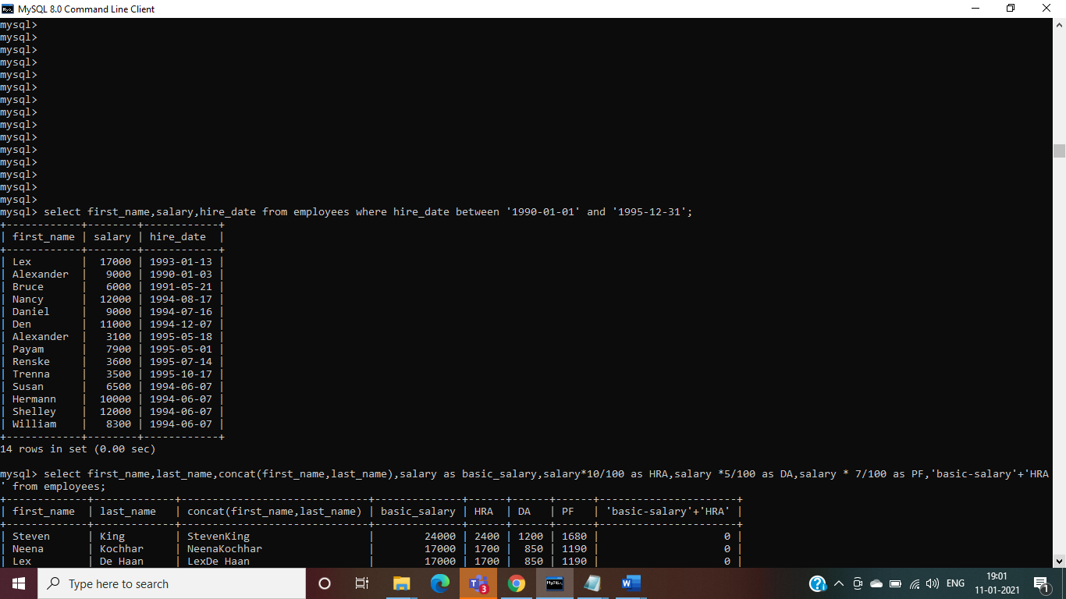

**Question-3**

**display the first name,department name and city using where clause and on clause**

**Answer-**

**Where Clause-**

select emp.employee_id,emp.first_name,dept.department_name,loc.city from employees emp,departments dept,locations loc where emp.department_id=dept.department_id and dept.location_id=loc.location_id;

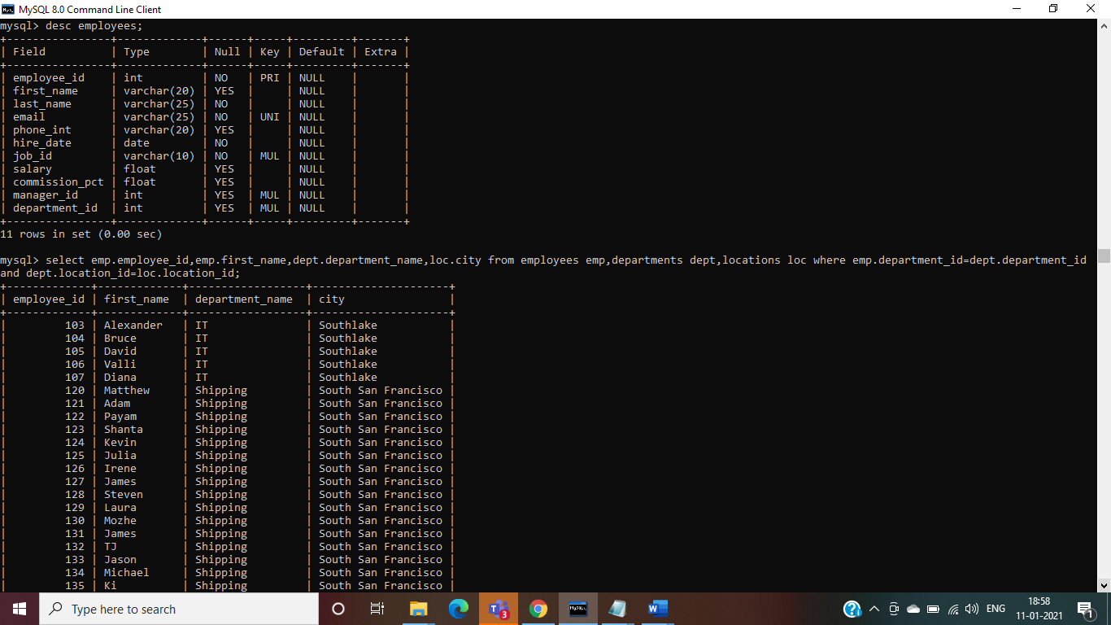

**on clause-**

select emp.employee_id,emp.first_name,dept.department_name,loc.city from employees emp inner join departments dept inner join locations loc on emp.department_id=dept.department_id and dept.location_id=loc.location_id;

